Spring Container Config with Java : No XML

In this section we will learn to configure Spring container with java annotation without requiring a config XML file.

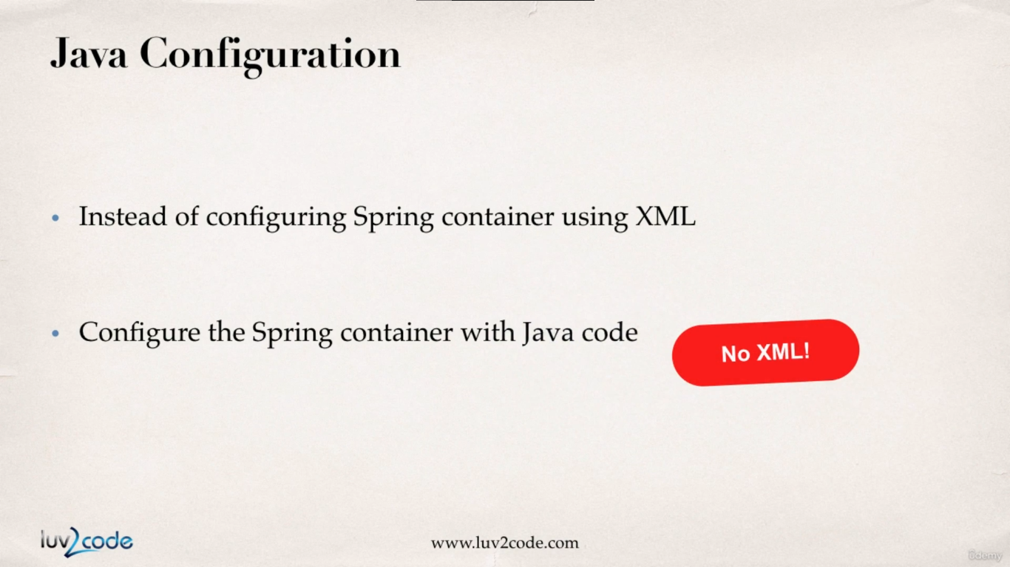

Various ways of Configuring a Spring Container

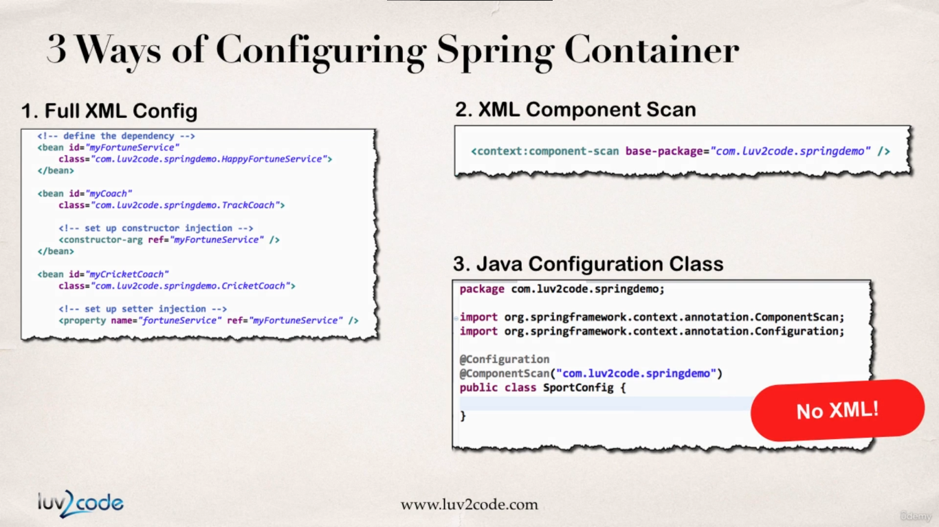

**Development process for config with no XML :**

1. Create a java class and annotate using **@Configuration**

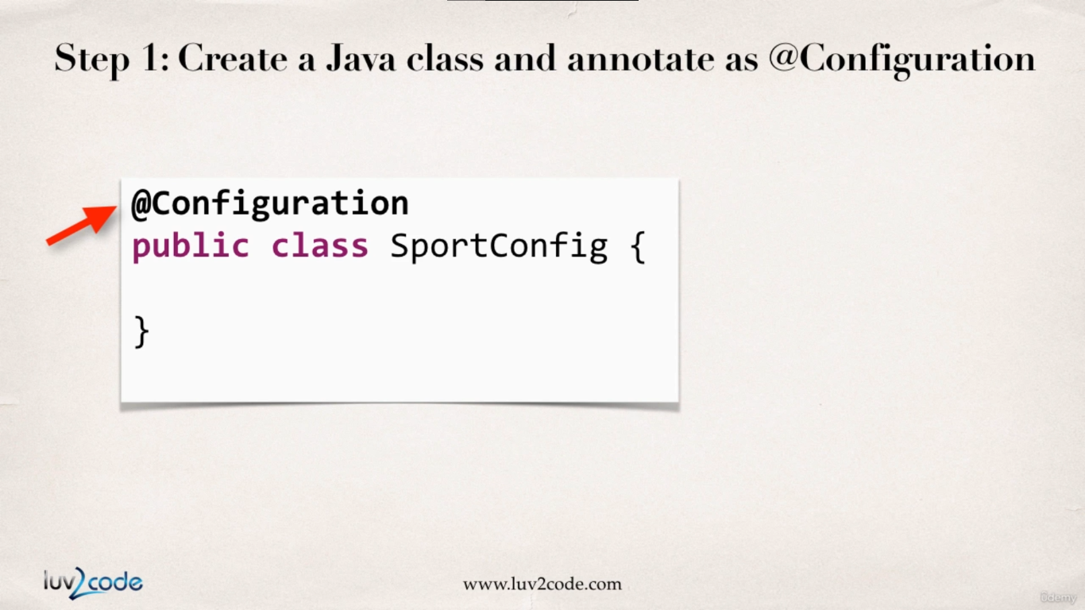

1. Add recursive component scanning using **@ComponentScan** (optional step)

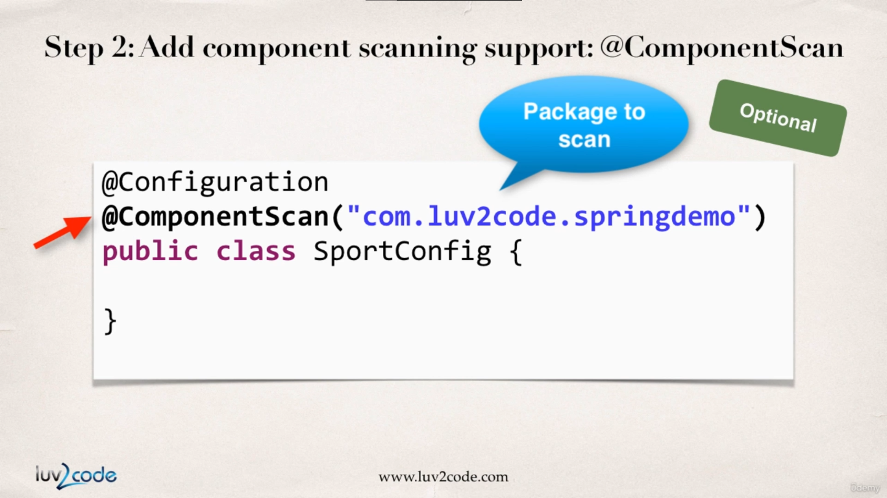

1. Read java configuration class, retrieve bean and call methods on the bean.

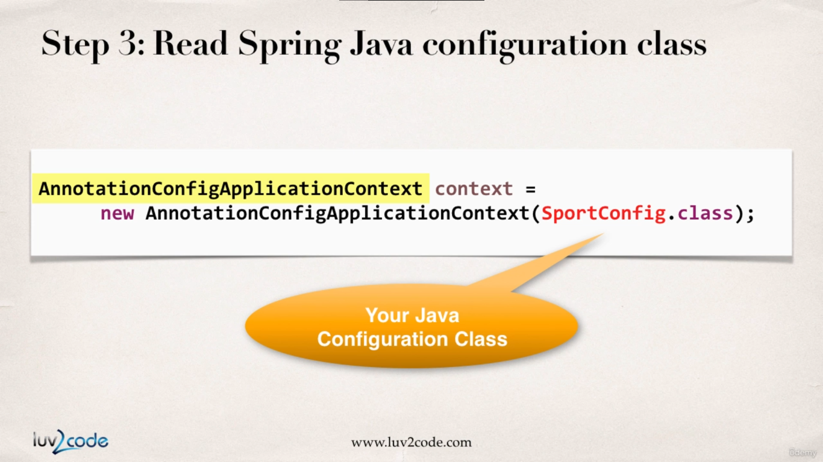

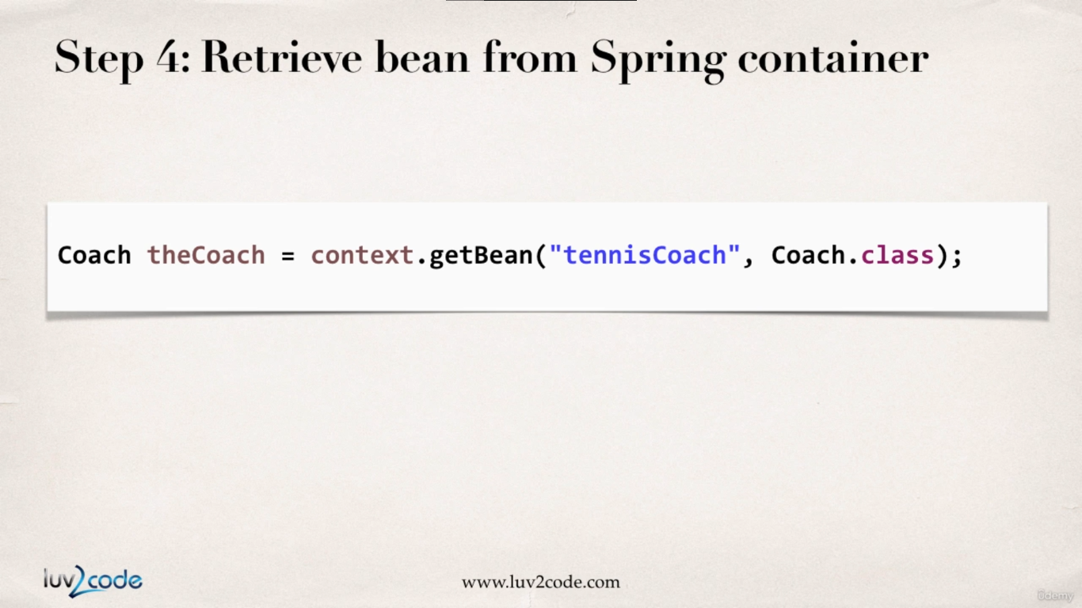

**SportConfig.java : (Configuration Class)**

**package** com.busybox.spring.anotations;

**import** org.springframework.context.annotation.ComponentScan;

**import** org.springframework.context.annotation.Configuration;

@Configuration

@ComponentScan("com.busybox.spring.anotations") // optional

**public** **class** SportConfig {

}

**FortuneService.java :**

**package** com.busybox.spring.anotations;

**public** **interface** FortuneService {

**public** String getDailyFotune();

}

**FortuneServiceImpl.java :**

**package** com.busybox.spring.anotations;

**import** org.springframework.stereotype.Component;

@Component

**public** **class** FortuneServiceImpl **implements** FortuneService {

@Override

**public** String getDailyFotune() {

**return** "well some good Fortune ";

}

}

**Coach.java :**

**package** com.busybox.spring.anotations;

**public** **interface** Coach {

**public** String getDailyWorkout();

**public** String getDailyFortune();

}

**TennisCoach.java :**

**package** com.busybox.spring.anotations;

**import** javax.annotation.PostConstruct;

**import** javax.annotation.PreDestroy;

**import** org.springframework.beans.factory.annotation.Autowired;

**import** org.springframework.beans.factory.annotation.Qualifier;

**import** org.springframework.beans.factory.annotation.Value;

**import** org.springframework.context.annotation.Scope;

**import** org.springframework.stereotype.Component;

@Component

@Scope("singleton")

**public** **class** TennisCoach **implements** Coach {

@Autowired

@Qualifier("fortuneServiceImpl")

FortuneService fortuneService;

@Value("${name}")

**private** String name;

@Value("${profession}")

**private** String profession;

**public** TennisCoach() {

System.out.println("TennisCoach() no-arg constructor");

}

**public** String getName() {

**return** name;

}

**public** String getProfession() {

**return** profession;

}

@Override

**public** String getDailyWorkout() {

**return** "Learn to Swing your racket";

}

@Override

**public** String getDailyFortune() {

**return** **this**.fortuneService.getDailyFotune();

}

// define bean init method

@PostConstruct

**public** **void** beanInitHook() {

System.out.println("beanInitHook()");

}

// define bean destroy method

@PreDestroy

**public** **void** beanDestroyHook() {

System.out.println("beanDestroyHook()");

}

}

**NoXMLJavaConfigDriver.java :**

**package** com.busybox.spring.anotations;

**import** org.springframework.context.annotation.AnnotationConfigApplicationContext;

**public** **class** NoXMLJavaConfigDriver {

**public** **static** **void** main(String[] args) {

// read spring config file

AnnotationConfigApplicationContext context = **new** AnnotationConfigApplicationContext(SportConfig.**class**);

// get the bean from spring container

TennisCoach tennisCoach = context.getBean("tennisCoach", TennisCoach.**class**);

// call a method on the bean

System.***out***.println(tennisCoach.getDailyWorkout());

System.***out***.println(tennisCoach.getDailyFortune());

// print values referenced from properties file

System.***out***.println(tennisCoach.getName());

System.***out***.println(tennisCoach.getProfession());

// close the context

context.close();

}

}

Output :

TennisCoach() no-arg constructor

beanInitHook()

Learn to Swing your racket

well some good Fortune

beanDestroyHook()

Define beans with Java Config : No XML

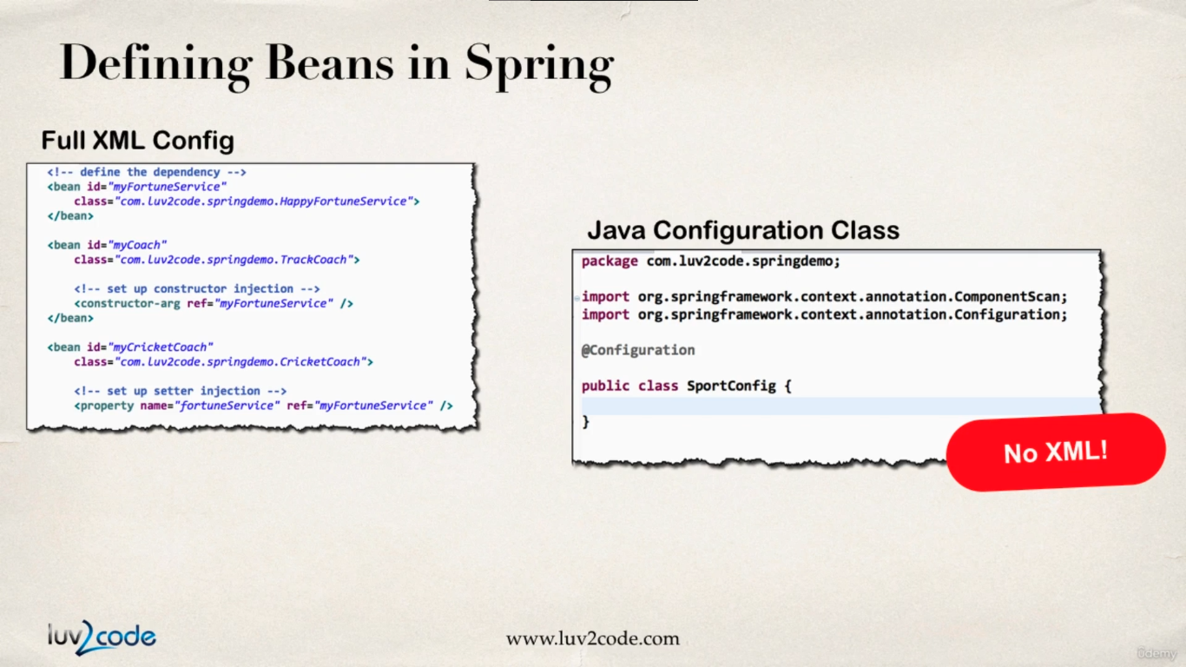

**Development Process :**

1. Define a method to expose bean with **@Bean**

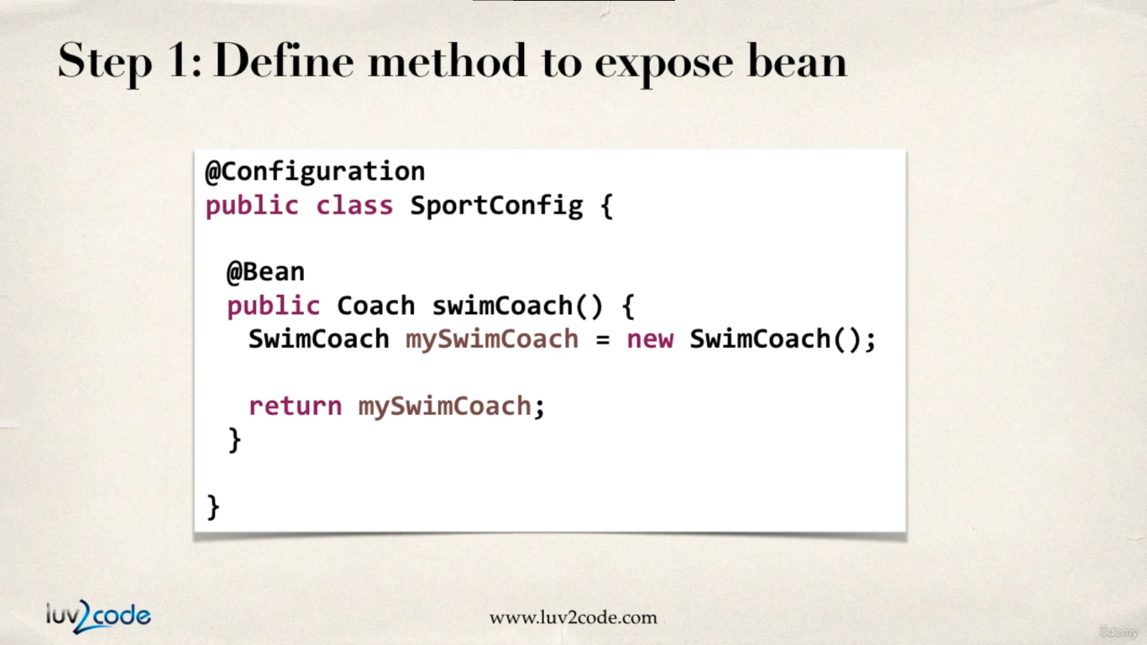

Well, here were are not doing a component scan to retrieve bean. In the java config file each and every bean is going to be defined individually. The method name to retrieve bean (in this case **swimCoach**) becomes the bean ID and gets registered in the spring container.

1. Inject bean dependencies

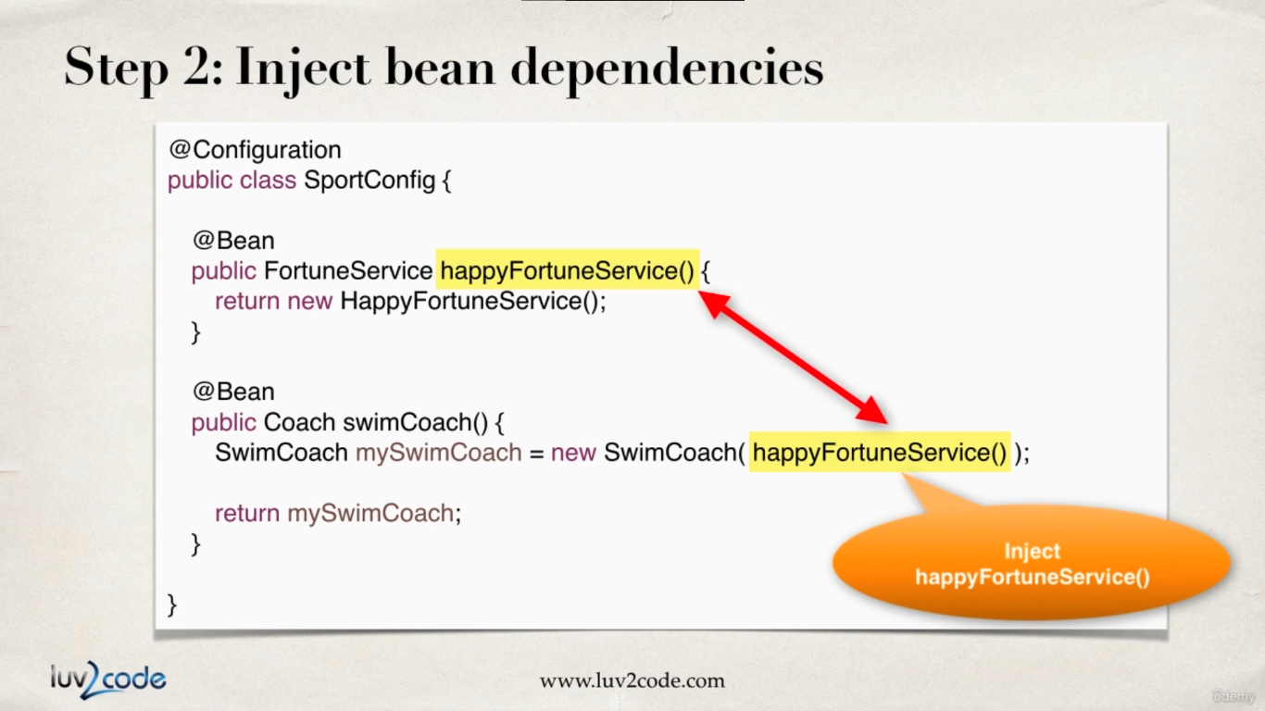

1. Read Spring Java configuration class

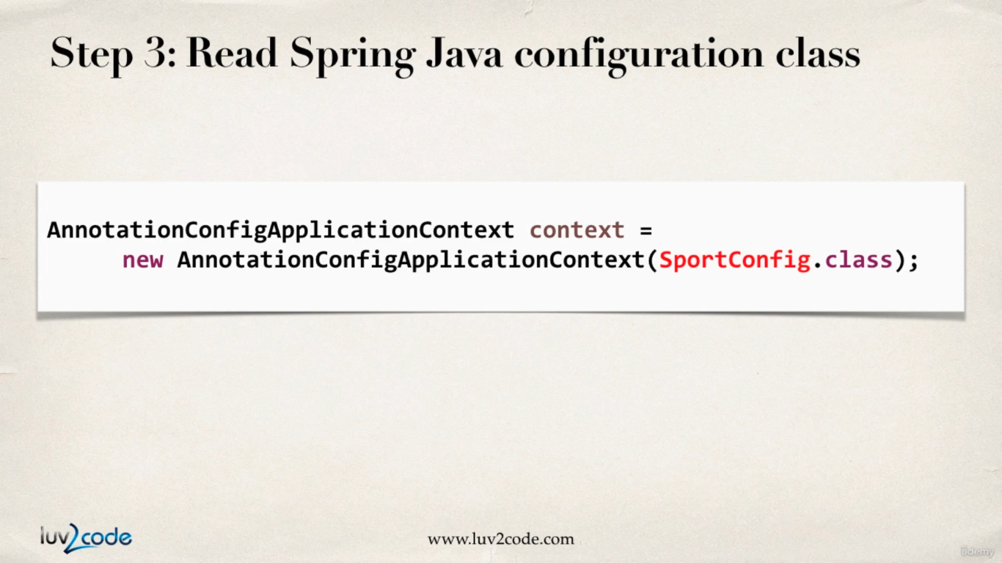

1. Retrieve bean from Spring container

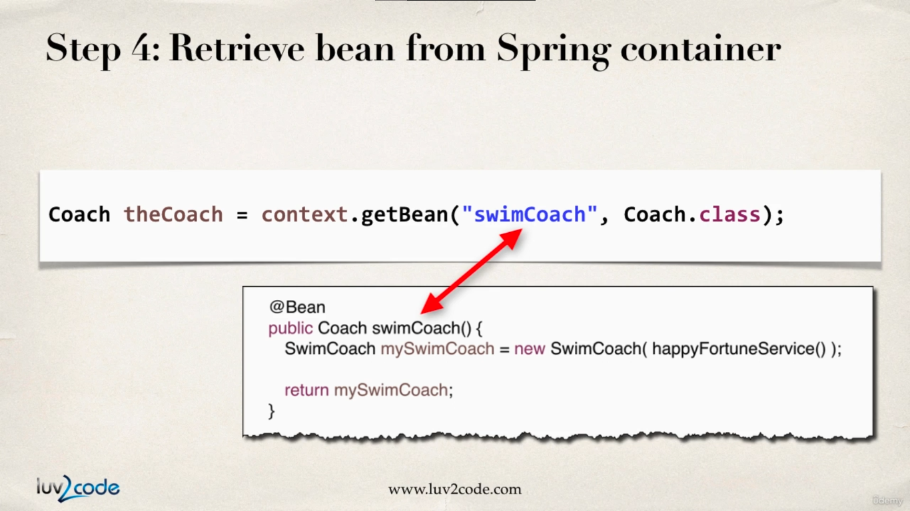

**FortuneService.java :**

**package** com.busybox.spring.anotations;

**public** **interface** FortuneService {

**public** String getDailyFotune();

}

**FortuneServiceImpl.java :**

**package** com.busybox.spring.anotations;

**import** org.springframework.stereotype.Component;

@Component

**public** **class** FortuneServiceImpl **implements** FortuneService {

@Override

**public** String getDailyFotune() {

**return** "well some good Fortune ";

}

}

**SadFortuneService.java :**

**package** com.busybox.spring.anotations;

**public** **class** SadFortuneService **implements** FortuneService {

@Override

**public** String getDailyFotune() {

**return** "Today is a sad Day :(";

}

}

**SwimCoach.java :**

**package** com.busybox.spring.anotations;

**public** **class** SwimCoach **implements** Coach {

**private** FortuneService fortuneService;

**public** SwimCoach(FortuneService fortuneService) {

**this**.fortuneService = fortuneService;

}

@Override

**public** String getDailyWorkout() {

**return** "swim 1000 meters as a warm up !!";

}

@Override

**public** String getDailyFortune() {

**return** **this**.fortuneService.getDailyFotune();

}

}

**SportConfig.java : (java config file)**

**package** com.busybox.spring.anotations;

**import** org.springframework.context.annotation.Bean;

**import** org.springframework.context.annotation.ComponentScan;

**import** org.springframework.context.annotation.Configuration;

@Configuration

@ComponentScan("com.busybox.spring.anotations") // optional

**public** **class** SportConfig {

// define bean for SadFortuneService

@Bean

FortuneService sadFortuneService() {

**return** **new** SadFortuneService();

}

// define bean for SwimCoach and Inject dependency

@Bean

SwimCoach swimCoach() {

**return** **new** SwimCoach(**this**.sadFortuneService());

}

}

**NoXMLJavaConfigDriver :**

**package** com.busybox.spring.anotations;

**import** org.springframework.context.annotation.AnnotationConfigApplicationContext;

**public** **class** NoXMLJavaConfigDriver {

**public** **static** **void** main(String[] args) {

// read spring config file

AnnotationConfigApplicationContext context = **new** AnnotationConfigApplicationContext(SportConfig.**class**);

// get the bean from spring container

TennisCoach tennisCoach = context.getBean("tennisCoach", TennisCoach.**class**);

Coach swimCoach = context.getBean("swimCoach", Coach.**class**);

// call a method on the bean

System.***out***.println(tennisCoach.getDailyWorkout());

System.***out***.println(tennisCoach.getDailyFortune());

// print values referenced from properties file

System.***out***.println(tennisCoach.getName());

System.***out***.println(tennisCoach.getProfession());

System.***out***.println(swimCoach.getDailyWorkout());

System.***out***.println(swimCoach.getDailyFortune());

// close the context

context.close();

}

}

**Output :**

TennisCoach() no-arg constructor

beanInitHook()

Learn to Swing your racket

well some good Fortune

swim 1000 meters as a warm up !!

Today is a sad Day :(

beanDestroyHook()

During All Java Configuration, how does the @Bean annotation work in the background?

For this code :

@Bean

SwimCoach swimCoach() {

**return** **new** SwimCoach();

}

At a high-level, Spring creates a bean component manually. By default, the scope is singleton. So, any request for a "swimCoach" bean, will get the same instance of the bean since singleton is the default scope.

However, let's break it down line-by-line

**@Bean**

The @Bean annotation tells Spring that we are creating a bean component manually. We didn't specify a scope so the default scope is singleton.

Coach swimCoach() {

This specifies that the bean will bean id of "swimCoach". The method name determines the bean id. The return type is the **Coach** interface. This is useful for dependency injection. This can help Spring find any dependencies that implement the **Coach** interface.

The @Bean annotation will intercept any requests for "swimCoach" bean. Since we didn't specify a scope, the bean scope is singleton. As a result, it will give the same instance of the bean for any requests.

**return** **new** SwimCoach();

This code returns an instance of the swimCoach.

Now let's step back and look at the method in it's entirety.

@Bean

public Coach swimCoach() {

SwimCoach mySwimCoach = new SwimCoach();

return mySwimCoach;

}

It is important to note that this method has the @Bean annotation. The annotation will intercept ALL calls to the method "swimCoach()". Since no scope is specified the @Bean annotation uses singleton scope. Behind the scenes, during the @Bean interception, it will check in memory of the Spring container (applicationContext) and see if this given bean has already been created.

If this is the first time the bean has been created then it will execute the method as normal. It will also register the bean in the application context. So that is knows that the bean has already been created before. Effectively setting a flag.

The next time this method is called, the @Bean annotation will check in memory of the Spring container (applicationContext) and see if this given bean has already been created. Since the bean has already been created (previous paragraph) then it will immediately return the instance from memory. It will not execute the code inside of the method. Hence this is a singleton bean.

The code for

SwimCoach mySwimCoach = new SwimCoach();

return mySwimCoach;

is not executed for subsequent requests to the method public Coach swimCoach() . This code is only executed once during the initial bean creation since it is singleton scope.

Now let’s understand how the dependency is injected :

return new SwimCoach(sadFortuneService())

This code creates an instance of **SwimCoach**. Note the call to the method **sadFortuneService()**. We are calling the annotated method above. The **@Bean** will intercept and return a singleton instance of **sadFortuneService**. The **sadFortuneService** is then injected into the swim coach instance.

Injecting Values from Property Files

**Development Process :**

1. Create a properties file

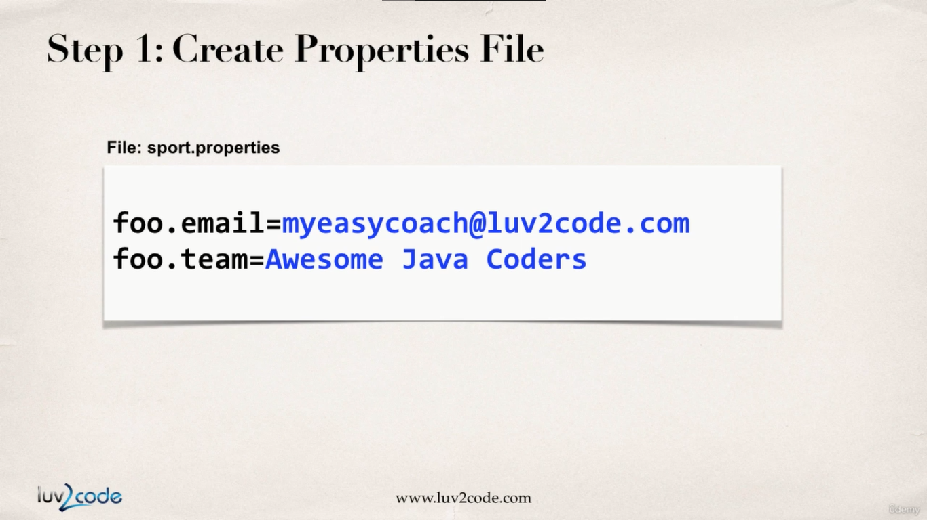

**Sport.properties :**

name = Rick Sanchez

profession = Mad Scientist

1. Load the properties file in the spring config.

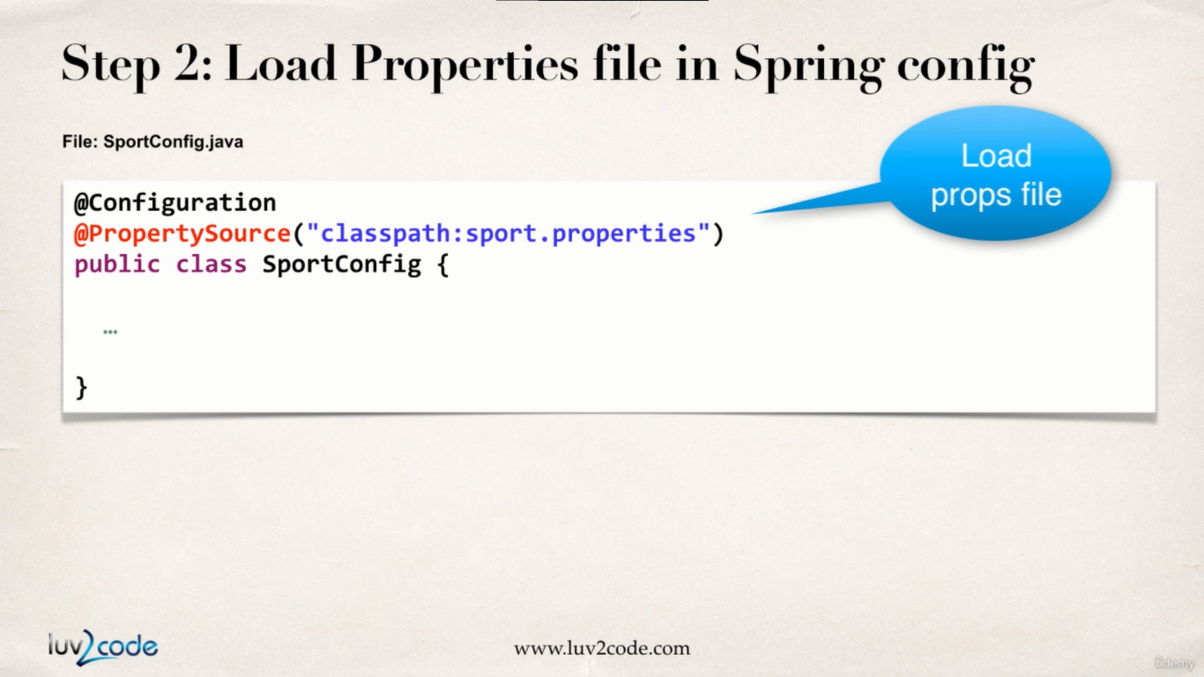

**SportConfig.java :**

**package** com.busybox.spring.anotations;

**import** org.springframework.context.annotation.Bean;

**import** org.springframework.context.annotation.ComponentScan;

**import** org.springframework.context.annotation.Configuration;

**import** org.springframework.context.annotation.PropertySource;

@Configuration

@ComponentScan("com.busybox.spring.anotations") // optional

@PropertySource("classpath:sport.properties") // loaded sport.properties file from class path

**public** **class** SportConfig {

// define bean for SadFortuneService

@Bean

FortuneService sadFortuneService() {

**return** **new** SadFortuneService();

}

// define bean for SwimCoach and Inject dependency

@Bean

SwimCoach swimCoach() {

**return** **new** SwimCoach(**this**.sadFortuneService());

}

}

1. Reference the values from properties file.

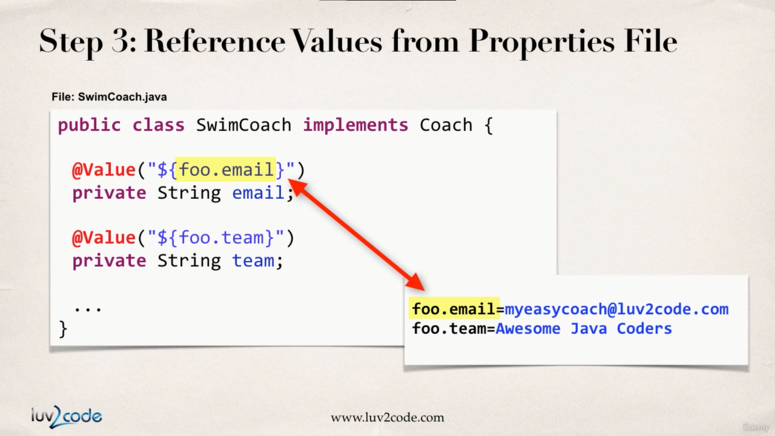

**SwimCoach.java :**

**package** com.busybox.spring.anotations;

**import** org.springframework.beans.factory.annotation.Value;

**public** **class** SwimCoach **implements** Coach {

**private** FortuneService fortuneService;

@Value("${name}")

**private** String name;

@Value("${profession}")

**private** String profession;

**public** SwimCoach(FortuneService fortuneService) {

**this**.fortuneService = fortuneService;

}

**public** String getName() {

**return** name;

}

**public** String getProfession() {

**return** profession;

}

@Override

**public** String getDailyWorkout() {

**return** "swim 1000 meters as a warm up !!";

}

@Override

**public** String getDailyFortune() {

**return** **this**.fortuneService.getDailyFotune();

}

}

**NoXMLJavaConfigDriver.java :**

**package** com.busybox.spring.anotations;

**import** org.springframework.context.annotation.AnnotationConfigApplicationContext;

**public** **class** NoXMLJavaConfigDriver {

**public** **static** **void** main(String[] args) {

// read spring config file

AnnotationConfigApplicationContext context = **new** AnnotationConfigApplicationContext(SportConfig.**class**);

// get the bean from spring container

TennisCoach tennisCoach = context.getBean("tennisCoach", TennisCoach.**class**);

SwimCoach swimCoach = context.getBean("swimCoach", SwimCoach.**class**);

// call a method on the bean

System.***out***.println(tennisCoach.getDailyWorkout());

System.***out***.println(tennisCoach.getDailyFortune());

// print values referenced from properties file

System.***out***.println(swimCoach.getName()); // Rick Sanchez

System.***out***.println(swimCoach.getProfession()); // Mad Scientist

System.***out***.println(swimCoach.getDailyWorkout());

System.***out***.println(swimCoach.getDailyFortune());

// close the context

context.close();

}

}